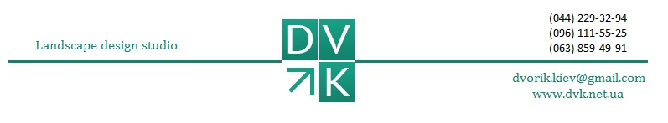
Lawns arranging and care
№ | Works list | Measurement units |  | Price, hrn
1 | Lawns arranging (not including seeds) | m² |  | from 20
2 | Laying rolled lawn (without excavation and material costs) | m² |  | from 15
3 | Fertilizing of lawn (excluding the cost of fertilizer) | m² |  | 1,5
4 | Lawn processing with selective herbicide (without the cost of material) | m² |  | 2,5
5 | Mowing the lawn with mower | m² |  | 1-10
6 | Aligning the edges of the lawn | m² |  | 2-6
7 | Weeding the lawn with hands | m² |  | 5-25
8 | Lawn scarification and aeration | m² |  | from 3
9 | Lawn combing | m² |  | 3-8
10 | Overseeding the lawn (not including seeds) | m² |  | from 35
Work on the flowerbeds and rock gardens creation
1 | An alpine slide mounting (without cost of materials) | m² | from 850
2 | Flower beds creating out of annuals and perennials | m² | 120-240
3 | Flowerbeds and rock gardens weeding with hands | m² | from 10
4 | Mulching | m² | 12
5 | Curb tape installing curb tape (without the cost of curb tape) | m | 11-17
Work on the trees and shrubs
planting
1 | Planting | un | 30% from materials price
2 | Planting of large-sized plants and exclusive |  | 35 % from materials price
3 | Author's supervision |  | 10% from materials price
4 | Transportation works (in fact) | km | 10

)

